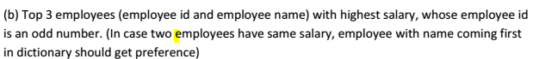

**Screenshots:-**

Created a reference named **‘a’** and referred the file named Employee_Details.txt.



Loaded the file that is referred by **‘a’** using dump command.



Please find the output of **“dump a”** below.

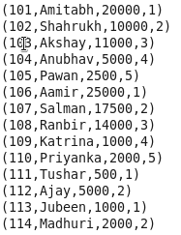

We need to find the result only for the employees with the employee id as odd number. So, We have **filtered odd employee id’s with the help of filter command.**

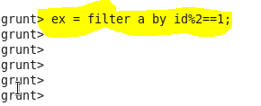

Loaded the file that is referred by **‘ex’** using dump command.



Please find the output of **“dump ex”** below.

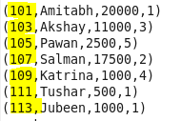

Below, we Ordered the file referred by ex with highest salary and if salaries are same, then order the id’s in ascending so that we can get the employee names coming first in the dictionary.

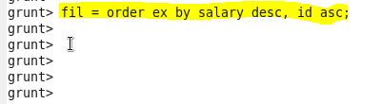

Loaded the file that is referred by **‘fil’** using dump command.



Please find the output of **“dump fil”** below.

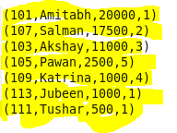

Using **Limit** command, we can **filter the first 3 tuples of ordered file** and is referred by **‘res’**

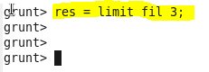

Loaded the file that is referred by **‘res’** using dump command.



Please find the output of **“dump res”** below.



Now in the output, **we need only the employee id’s and names of the file referred by res.**

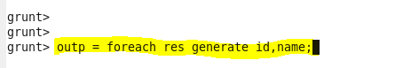

We have **loaded the file that is referred by outp** using dump command**.**



You can find the required result below.

